**QUICK REFERENCE NUMBERS*:***

**EMERGENCY: 911**

**FIRE: 772-621-3508**

**(NON-EMERGENCY)**

**POLICE**: **772-462-3226**

**HURRICANE INFO: 772-461-5201**

**COMMUNITY MANAGER:**

**Patty Hobbs, LCAM**

**EMAIL: Islanddunes1@comcast.net**

**OFFICE: 772-229-8415**

**WEBSITE: www.Idoceanside1.com**

**SECURITY: 772-229-9500**

**COUNTRY CLUB OFFICE:**

**772-229-0803**

**COUNTRY CLUB PRO-SHOP: 772-229-2739**

**COUNTRY CLUB TENNIS:**

**772-229-8461**

**COUNTRY CLUB RESTAURANT:**

**772-229-7575**

**(PIETRO’S ON THE RIVER)**



**A full list of our Rules & Regulations are available in the Island Dunes I office.**

**We hope you enjoy your stay at**

**Island Dunes Oceanside I**



ISLAND DUNES

OCEANSIDE I

8880 SOUTH

OCEAN DRIVE

JENSEN BEACH, FLORIDA 34957

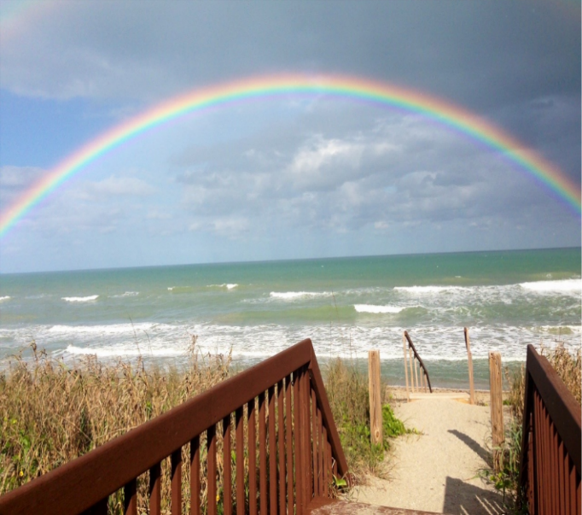 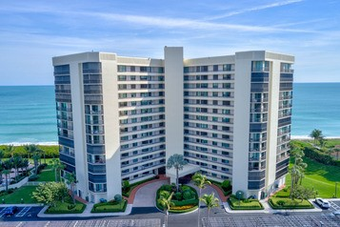

[Customized

Turnkey Training

Courseware]

**BASIC CONDO RULES**

**Island Dunes Oceanside I is a friendly neighborhood located in the beautiful Treasure Coast City of Jensen Beach on Hutchinson Island.**

**Being a part of the Island Dunes Oceanside I community offers our residents a tropical paradise lifestyle. Island Dunes Oceanside I is a true jewel with many amenities such as direct beach access, spacious outdoor areas with two (2) heated swimming pools, a hot tub, an exercise room, a game room, a social room, and much more. Our amenities are just a backdrop to the real benefit of living at Island Dunes Oceanside I- the people.**

**In addition to beautiful scenic waterfront views of the Treasure Coast, there are great outdoor activities available at the Island Dunes Country Club, including an executive nine-hole golf course along the Indian River, a state-of-the-art tennis facility, and pickleball courts. Furthermore, the town of Jensen Beach offers upscale dining, beautiful beaches, top notch shopping, and an entertaining nightlife, all at your fingertips.**

**Island Dunes Oceanside 1 is truly an amazing and special place making for a wonderful lifestyle choice and an incredible experience.**

**IMPORTANT**

**HIGHLIGHTS OF RULES &**

**REGULATIONS**

**UPON ARRIVAL:**

* **Guests will not be admitted without prior registration with the Manager’s Office at (772-229-8415) or with Security at**

**(772-229-9500).**

* **Unit Owners, renters, and guests upon arrival must register with Security and obtain a parking sticker/window card for vehicle identification.**
* **Guests shall return the Guest Registration form to the Office that they receive from Security.**
* **A Unit Owner who intends to have guests occupy their unit while the Owner is not in residence must notify the Manager’s Office in advance of the guest’s visit.**
* **All vehicles must be checked in with Security.**
* **ALL vehicles must have an Island Dunes permanent sticker or a temporary pass.**
* **NO vehicles are to be backed into spaces.**
* **Parking under the Main Entrance (PORTICO) is permitted only for loading/unloading.**
* **Guest vehicle parking is located in the North section of the Parking Area.**
* **Pick-up trucks and Vans are to be parked in the parking area along the west wall (next to the public road).**
* **No moving vans, trailers, commercial vehicles, RV’s or boats may be parked in the parking area except with approval of the Manager’s Office.**
* **ALL vehicles must abide by the 10 MPH speed limit.**
* **Smoking is NOT permitted in common areas.**
* **POOL: Access to the pool area must be made through the Building lobby.**
* **Showers are available and are required before entering the pool or the hot tub area.**
* **Everyone MUST be thoroughly dried off**

**before entering the Building.**

* **Shoes & Cover- Up’s must be worn in all common areas.**
* **For reasons of safety, NO running is permitted in the pool area.**
* **A responsible adult must supervise all children (12 & under).**
* **NO child under twelve (12) years of age is permitted in the hot tub area under any circumstances.**
* **NO lifeguard is on duty.**
* **NO diapers are allowed to be worn inside the pool or hot tub at any time.**
* **Glass containers are NOT permitted in the pool area and for safety reasons must NOT be used.**
* **Towels are to be placed on any outdoor furniture while sunbathing.**
* **Electronic equipment such as radios, tape recorders, ipods, are NOT permitted in the pool area unless headphones are in use.**
* **Consideration of others using the facilities and the application of “The Golden Rule” is expected of everyone.**
* **NO items including towels shall be hung on your unit’s balcony.**
* **Unit Owners may have one (1) pet that must not exceed the maximum weight of (30) pounds which needs to be approved by the Manager’s Office and Board of Directors prior to arrival.**
* **Pets must be carried or in a stroller through all Common Areas of the Building and to be on a leash while outside.**
* **Owners shall be responsible and liable for their pet’s behavior and actions, also must be responsible for picking up and disposing of their pet’s waste in the containers provided in the outside areas.**
* **Guests and Renters are NOT permitted to have pets.**